Introduction

Student performance has been a bit worrying, and various stakeholders are concerned about the situation. To address this issue, a data team has been brought on board to see the best way to solve the problem. To solve this problem, various variables were examined, and certain insights were extracted. The key insights and solutions generated from this project are presented below.

Analysis

In order to identify reasons for underwhelming student performance, for a set of students, the following key variables were examined:

- Age

- Gender

- Weekly library hours

- Weekly general class attendance

- Weekly extra-curricular hours

- Parent income level

- Previous Exam Score

The relationship between each of the variables and previous exam score were examined, and the results are presented next.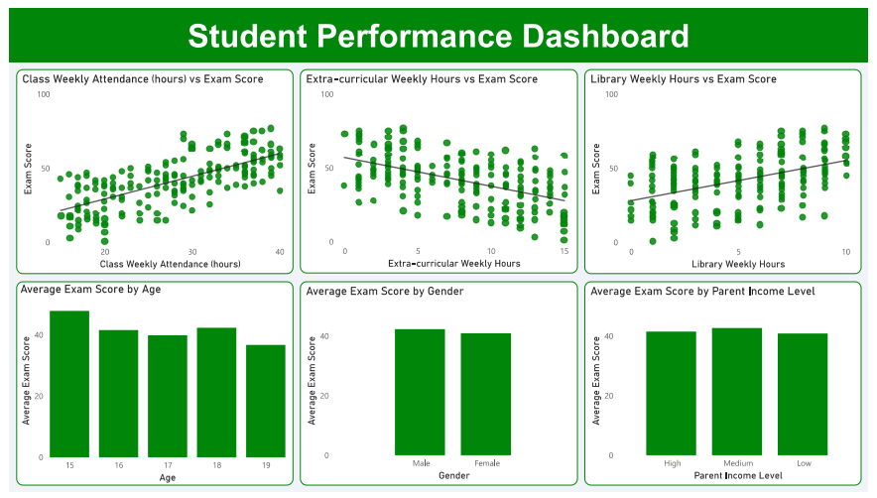

These variables were found to have a relationship with student performance:

* Class attendance
* Extra-curricular activities
* Library time
* Age

On the other hand, the following were not:

* Gender
* Parent income level

Proposed Solution

To improve student performance, the following actions are recommended:

* Implement strategies to improve class attendance. Things like impromptu tests and tying exam access to class attendance can be implemented.
* Implement strategies to improve library attendance. Things like mandatory library hours can be implemented.
* Reduce extra-curricular activities, especially at the SS3 level.
* Although age had a weak relationship, since older students were discovered to perform poorer, special attention can be given to older students, such as opportunities for lessons.